LZ4 Streaming Format

Notices
Copyright (c) 2013 Yann Collet
Permission is granted to copy and distribute this document for any purpose and without charge, including translations into other languages and incorporation into compilations, provided that the copyright notice and this notice are preserved, and that any substantive changes or deletions from the original are clearly marked.
Version
1.3
Introduction
The purpose of this document is to define a lossless compressed data format, that is independent of CPU type, operating system, file system and character set, suitable for File compression, Pipe and streaming compression using the LZ4 algorithm : http://code.google.com/p/lz4/
The data can be produced or consumed, even for an arbitrarily long sequentially presented input data stream, using only an a priori bounded amount of intermediate storage, and hence can be used in data communications. The format uses the LZ4 compression method, and xxHash-32 checksum method, for detection of data corruption.
The data format defined by this specification does not attempt to allow random access to compressed data.
This specification is intended for use by implementers of software to compress data into LZ4 format and/or decompress data from LZ4 format. The text of the specification assumes a basic background in programming at the level of bits and other primitive data representations.
Unless otherwise indicated below, a compliant compressor must produce data sets that conform to all the specifications presented here.
A compliant decompressor must be able to accept and decompress at least one data set that conforms to the specifications presented here; whenever it does not support any parameter, it must produce a non-ambiguous error code and associated error message explaining which parameter value is unsupported (a typical example being an unsupported buffer size).
Distribution of this document is unlimited.

Overview : Description of a stream
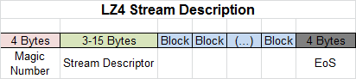

Magic Number
4 Bytes, Little endian format.
Value : 0x184D2204

Stream descriptor
2 to 14 Bytes, to be detailed in the next part.
Most significant part of the spec.

Data Blocks
To be detailed later on.
That’s where compressed data is stored.

End of Stream mark
The stream ends when the last data block has a size of “0”.
The size is expressed as a 32-bits value.

Concatenation
It shall be possible to append 2 streams. In this case, the decoder shall be able to decode them both, by appending the results in the same order.
Stream Descriptor
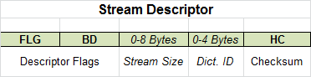
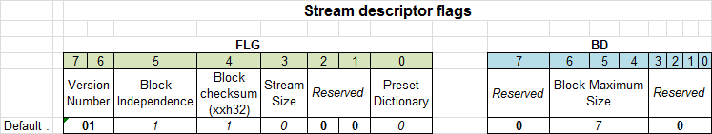
The stream descriptor uses a minimum of 3 bytes, and up to 15 bytes depending on optional parameters.
In the picture, bit 7 is highest bit, while bit 0 is lowest.

Version Number :
2-bits field, must be set to “01”.
Any other value can not be decoded by this version of the specification.
Other version numbers will use different flag layouts.
Block Independence flag :
By default, blocks are independent, and can therefore be decoded independently.
If this flag is set to “0”, it means each block depends on previous ones for decoding (up to LZ4 window size, which is 64 KB). In this case, it’s necessary to decode all blocks in sequence.
Block dependency improves compression ratio, especially for small blocks. On the other hand, it makes jumps or multi-threaded decoding impossible.
Default value : “1” (blocks are independent)

Block checksum flag :
If this flag is set, each data block will be followed by a 4-bytes checksum, calculated by using the xxHash-32 algorithm on the raw (compressed) data block.
The intention is to detect data corruption (storage or transmission errors) immediately, before decoding.
Default value : “1” (enabled)

Stream Size flag :
If this flag is set, the original (uncompressed) size of the full stream will be present as a 8 bytes unsigned value, right after the flags.
Default value : “0” (not present)

Preset Dictionary flag :
If this flag is set, a Dict-ID field will be present, right after the descriptor flags and the stream size.
Default value : “0” (not present)

Block Maximum Size :
This information is intended to help the decoder allocate the right amount of memory.
Size here refers to the original (uncompressed) data size.
Block Maximum Size is one value among the following table :
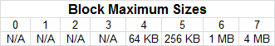
The decoder may refuse to allocate block sizes above a (system-specific) size.
Unused values may be used in a future revision of the spec. A decoder respecting the current version of the spec shall be unable to decode such stream.

Reserved bits :
Value of reserved bits must be 0 (zero).
Reserved bit might be used in a future version of the specification, to enable any (yet-to-decide) optional feature.
If this happens, a decoder respecting the current version of the specification shall not be able to decode such a stream.

Stream Size
This is the original (uncompressed) size.
This information is optional, and only present if the associated flag is set.
Stream size is provided using unsigned 8 Bytes, for a maximum of 16 HexaBytes.
Format is Little endian.
This field has no impact on decoding, it just informs the decoder how much data the stream contains (for example, to display it during decoding process).

Dictionary ID
Dict-ID is only present if the associated flag is set.
A dictionary is specially useful to compress short input sequences. The compressor can take advantage of the dictionary context to encode the input in a more compact manner. It works as a kind of “known prefix” which is used by both the compressor and the decompressor to “warm-up” reference tables and help compress small data blocks.
Dict-ID is the xxHash-32 checksum of this “known prefix”. Format is Little endian.
The decompressor uses this identifier to determine which dictionary has been used by the compressor. The compressor and the decompressor must use exactly the same dictionary. This document does not specify the contents of predefined dictionaries, since the optimal dictionaries are application specific. Any data format using this feature must precisely define the allowed dictionaries.
Within a single stream, a single dictionary is possible.
When the stream consists of multiple independent blocks, each block will be initialised with the same dictionary.
If the stream consists of interdependent blocks, the dictionary will only be used once, at the beginning of the stream.

Header Checksum :
One-byte checksum of all descriptor fields, including optional ones when present.
The byte is second byte of xxh32() : { (xxh32()>>8) & 0xFF } ,
using zero as a seed,
and the full Stream Descriptor as an input (including optional fields when they are present).
A different checksum indicates an error in the descriptor.
Data Blocks
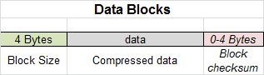

Block Size
This field uses 4-bytes, format is little-endian.
The highest bit is “1” if data in the block is uncompressed.
The highest bit is “0” if data in the block is compressed by LZ4.
All other bits give the size, in bytes, of the following data block (the size does not include the checksum if present).
Block Size shall never be larger than Block Maximum Size. Such a thing could happen when the original data is incompressible. In this case, such a data block shall be passed in uncompressed format.

Data
Where the actual data to decode stands. It might be compressed or not, depending on previous field indications.
Uncompressed size of Data can be any size, up to “block maximum size”.
Note that the data block is not necessarily filled : an arbitrary “flush” may happen anytime. Any block can be “partially filled”.

Block checksum :
Only present if the associated flag is set.
This is a 4-bytes checksum value, in little endian format,
calculated by using the xxHash-32 algorithm on the raw (compressed) data block,
and a seed of zero.
The intention is to detect data corruption (storage or transmission errors) before decoding.
The xxHash-32 algorithm is much faster than CRC32. It offers great distribution properties, rigorously checked with SMHasher test tool. Fast and portable 32-bits checksum is a necessity to match the speed of LZ4 decoder. xxHash fit the bill by being approximately 5x faster than LZ4 decoder, reducing the overall speed by at worst 20%, usually less when data is compressible.
Legacy format
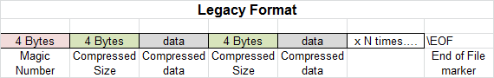
The Legacy format was defined into the initial versions of “LZ4Demo”.
Newer compressors should not use this format anymore, since it is too restrictive.
It is recommended that decompressors shall be able to decode this format during the transition period.
Main properties of legacy format :
- Fixed block size : 8 MB.
- All blocks must be completely filled, except the last one.
- The last block is detected either because it is followed by the “EOF” (End of File) mark, or because it is followed by a known Magic Number.
- No checksum
- Convention is Little endian

Magic Number
4 Bytes, Little endian format.
Value : 0x184C2102
Block Compressed Size
This is the size, in bytes, of the following compressed data block.
4 Bytes, Little endian format.
Data
Where the actual data stands.
Data is always compressed, even when compression is detrimental (i.e. larger than original size).
Appendix : Version changes
1.3 : modified header checksum
1.2 : reduced choice of “block size”, to postpone decision on “dynamic size of BlockSize Field”.
1.1 : optional fields are now part of the descriptor
1.0 : changed “block size” specification, adding a compressed/uncompressed flag
0.9 : reduced scale of “block maximum size” table
0.8 : removed : high compression flag
0.7 : removed : stream checksum
0.6 : settled : stream size uses 8 bytes
settled : endian convention is little endian
0.5: added copyright notice
0.4 : changed format to Google Doc compatible OpenDocument

